PHY 111 Lecture Note
Lecturer: Abubakar Abdulkadir
Unit: 3 Credit Load

COURSE CONTENT/LECTURE NOTES
- HYDROSTATICS
- Definition of Hydrostatic, Density and Pressure
- Archimedes Principle
- Laminar and Turbulent flows
- Viscosity, factors affecting viscosity
- Stoke’s Law & Terminal Velocity
- SURFACE TENSION, ADHENSION, COHESION & CAPILARITY
- Definition of surface tension, evidence of surface tension & factors affecting surface tension.
- Surface tension in terms of Energy
- Angle of contact, Adhesion & cohesion
- Capillarity and its application
- Experimental Determination of surface tension by capillary method.
- Excess pressure - Drops & bubbles
- HEAT & TEMPERATURE
- Concept of Heat and Internal Energy
- Temperature and Zeroth law of Thermodynamics
- Thermodynamics temperature scales
- Thermometer (types of thermometers and their calculations)

HYDROSTATICS
Hydrostatic also referred to as fluid (at rest) statics is a branch of fluid mechanics that deals with the condition of equilibrium of a floating body or a submerged body and the pressure on the fluid, or exerted by the fluid on an immersed body.
In summary hydrostatics study condition of equilibrium of a floating body, body submerged in liquid, the pressure within a liquid and also the pressure exerted by fluid on a submerged body.

Applications of Hydrostatics
- It explains the phenomenon of why wood and oil float in water.
- It is also provide a means for calculating problems relating to pressure deep water and change in altitude i.e. pressure increases with increase in altitude. The pressure have the atmosphere pressure which is the pressure within the atmosphere.

Hydrostatic Pressure: This is the pressure that is acted on the body when it is immersed in water to a certain depth. The hydrostatic pressure works on the principle of hydrostatics which states that the pressure exerted on the immersed object by the fluid is directly and to the depth of the object from the free surface of the fluid.

Density: It is a measurement that comprises the amount of matter an object has (mass) to its volume. An object with much matter in a certain volume has a high density and vice versa. It is essentially a measurement of how tightly matter is packed together. It is represented by a symbol $ρ$ (rho) simply defined mass per unit volume of the object.

Since mass is measured in kg and volume in m³ then it follows that the unit of density is kg/m³ (kilogram per cube metre cube).

Unit of Density
- Though the SI Unit of density is kg/m³, for convenience we use g/cm³ for solids, g/mL for liquid and g/L for gases.
- Density can be explained as the relationship between mass of the surface and the volume it takes up.
- In a quantitative term, it shows how much heavy an object is at constant volume.
- Different substance have different densities, which means the same volume of different substances weigh differently

PRESSURE
Pressure is the amount of force applied perpendicular to the surface of an object per unit area. It has a symbol P. Mathematical, pressure is defined as
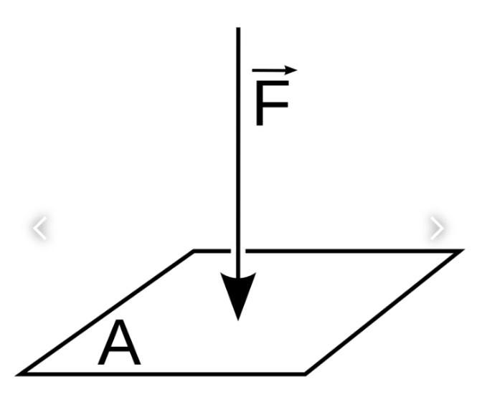
$$P=\frac{F}{A}$$

Where A is the area of the surface in contact. The S.I unit for pressure is Pascal (Pa) equal to one newton per square meter (N/m²).
i.e. Pa= N/m³ or Kg/ms²

Archimedes Principle
Archimedes principle states that when a solid figure is immersed in a container filled with water, then the volume of water that overflows (was displaced from the container is equal to the volume of the solid figure.
In a more general way, the Archimedes principle states that;
Anybody completely or partially submerged on a fluid (gas or liquid) at rest is acted upon by an upward force (buoyant force), the magnitude of which is equal to the weight of the fluid displaced by the body.

Note: The buoyant force on a body floating on a liquid or gas is also equivalent in magnitude to the weight of the floating object and is opposite in direction.

Archimedes Principle Formular
Buoyant force of the object is equal to the weight of the fluid displaced by the object.
Mathematically, $F_{b}=mg$

or
$$F_{b}=ρ×v×g$$

Where $ρ$ the density of the liquid, V is is the volume of fluid displaced and g is the acceleration due to gravity.
[
NB: Upthrust is also equal to buoyant force.

Solved Problems
- Calculate the resulting force of a steel ball of radius 6cm is immersed in water.
Solution
From Archimedes Principle formula,
$$F_{b}=ρvg$$
Where $ρ$ = density of the liquid (water) = 1000kg/m³
V = Vol. of the water displaced = vol. of the solid figure (steel ball) = $\frac{4}{3}πr^{3}$ = vol. of a sphere = $\frac{4}{3}π{0.06}^{3}$ = 9.05 $×$ 10⁻⁴m³
$∴$ $F_{b}$ = 1000 $×$ 9.8 $×$ 9.05 $×$ 10⁻⁴
$F_{b}$ = 8.87N

Application of Archimedes Principle
The principle is used in the design of ships and submarines.
- The Hot air balloon works also on the Archimedes principle

LAMINAR & TURBULENT FLOW
Laminar Flow:
The smooth flow of fluid, with velocity smaller than certain critical velocity (limiting value of velocity, is called streamline or Laminar flow.

Turbulent Flow:
The irregular and unsteady flow of a fluid. When its velocity increases beyond critical velocity are called turbulent flow.

Differences the two flows
S/N | Streamline Flow | Turbulent flow
 | The velocity of liquid is low and steady | The velocity of liquid is high and unsteady
 | Velocity of liquid is below a certain critical velocity | The velocity of flow is greater than a certain critical velocity
 | The velocity of every particle of liquid having a particular point is same | The velocity, of every particle of liquid keeps changing at any instant.
 | In a laminar flow, fluid flow in parallel layer through the wall of the pipe such that there is no intermixing of layers. | Intermixing or disruption occurs as fluid flow is not parallel through the wall of the pipe.

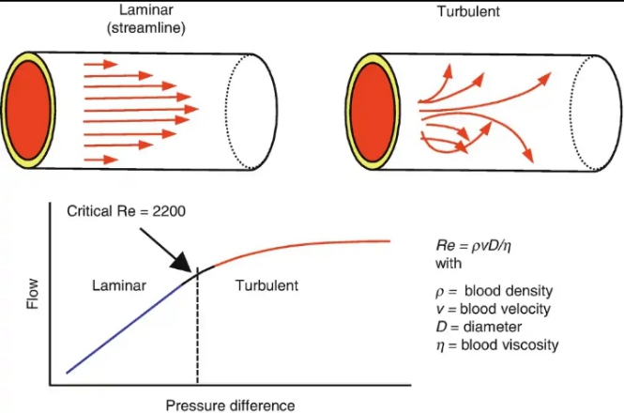

Raynolds’s Number
Having talked about the laminar and turbulent flow, we can actually predict the type of flow when we consider the Raynold’s number. It is a dimensionless number represented by the following relationship
$ρ$ is the density of the fluid
V is the velocity of fluid m/s
L is the diameter (Length) of the fluid (m)
$μ$ is the viscosity of fluid (Ns/m²) or PaS.
$$R_{e}=\frac{ρvL}{μ}=\frac{inertia force}{visous force}$$

Based on the different value $R_{e}$ we can infer that if $R_{e}$ < 2000, flow is laminar
If $R_{e}$ > 4000, the flow turbulent
If 2000 < $R_{e}$ > 4000, flow is transition

Solved Problems
Calculate the Reynold’s number of a fluid having viscosity of 0.4Ns/m² and relative density of 900kg/m³ is flowing through a pipe of 20mm with velocity of 2.5m/s.
Solution${using; R}_{e}=\frac{ρvL}{μ}=\frac{900×2.5×20×{10}^{-3}}{0.4}=112.5$
Since $R$ < 2000 then flow is Laminar.

VISCOSITY
Viscosity of a fluid (liquid or gas) is a quantity that measures the fluid resistance to flow.
Viscosity can also be thought of as a measure of fluid thickness or its resistance to objects passing through it.
Viscosity tires to describe the internal friction of a moving fluid. A fluid with larger viscosity, resist motion between its molecular makeups gives it a lot of internal friction. A fluid with low viscosity flows easily between its molecular make up results in very little friction when it is in motion.

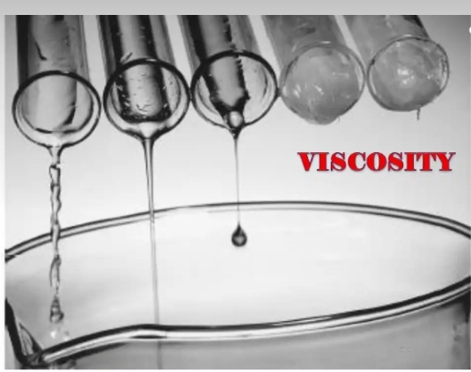

The S.I unit of viscosity is the Poiseiulle (Pi). Other units are Newton Second per Square meter (Nsm⁻²). PaS with a dimension of ML⁻¹T⁻¹

Factors that Affect Viscosity
- Temperature
- Pressure
- Nature of Fluid
- Velocity of Gradient

STOKES LAW & TERMINAL VELOCITY
It is true that when an object rises or falls though a fluid it will experience a viscous drag (Frictional Force) due to the fluid. The object could be a stone or sphere falling through water or bubbles rising through water.
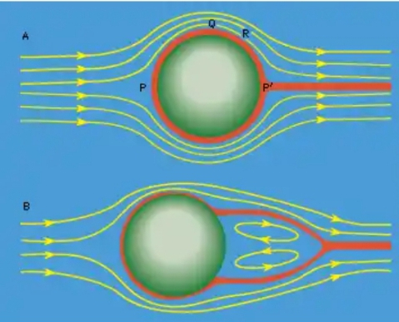
Statement of Stoke’s Law: It states that the viscous drag force on a sphere of radius, r, moving with a velocity of V in a fluid of viscosity $η$ is given by
1
$$F=6πηrv$$

NB: The law is valid only for Laminar flow.
Where F, is the frictional force (viscous drag acting on the surface between the fluid and the particle (sphere).
$r$, is the radius of the spherical object.
$v$, is the flow velocity (Terminal Velocity) of the object within the viscous liquid.
$η$, is the fluid viscosity.
From the equation we can summarize that the frictional force or the viscous drag is proportional to the flow velocity, fluid viscosity and radius of the sphere.

Terminal Velocity
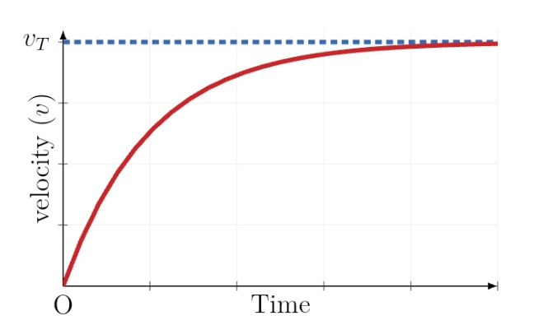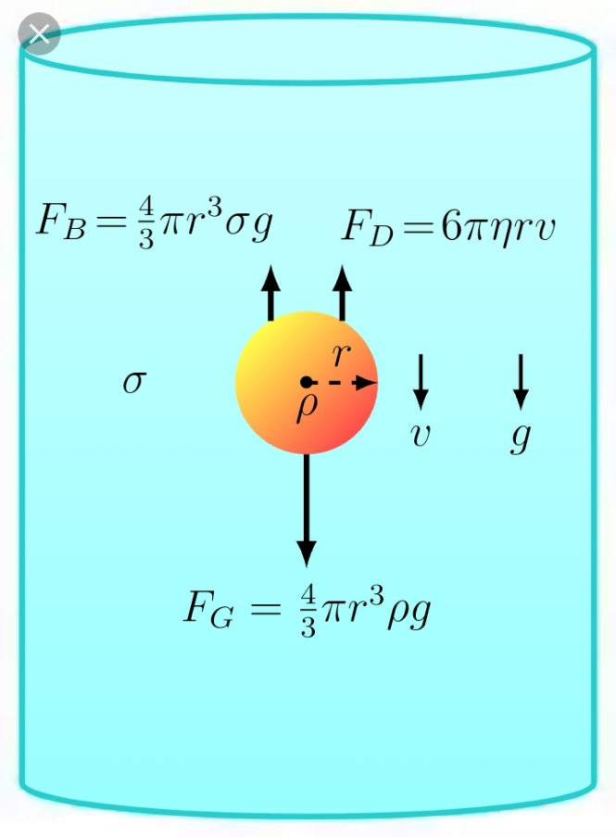 When a sphere is falling through a viscous liquid it is subjected to three forces; it weight acting downwards, the upthrust (buoyant force), U, of the liquid and the viscous force, F, acting upwards.
The equation of motion of the sphere will be;
1
$$F_{Net}=W-\left(U+F\right)=ma$$
where 'a' is the acceleration of stone falling through the liquid and m, is it's mass
As the stone fall faster and faster through the liquid, the viscous drag (force) opposing the motion increases (i.e viscous force increase with increase in speed or velocity of sphere) until a maximum velocity is reached when the viscous drag (force) balances the downward force, the sphere moves with a constant velocity because acceleration is zero (a = 0). This constant velocity is termed terminal velocity and therefore equation 1 reduces to;
2
$$W=U+F$$
Where $W=mg=ρvg=\frac{4}{3}πr^{3}ρg$
3
For $v$, the volume of sphere, $ρ$ is the density of the material of sphere.
The Upthrust (buoyant) force equals the weight of the liquid displaced then
4
$$v=mg=σvg=\frac{4}{3}πr^{3}σg$$
for $v$, volume of liquid displaced and
$σ,$ the density of liquid.
According to Stoke’s, the viscous forces acting upward is given by
5
$$F=6πηrv$$
putting equation (5), (4), (3) in (2) gives;
$\frac{4}{3}πr^{3}ρg= 6π ηrV$ + $\frac{4}{3}πr^{3}σg$
or $6π ηrV$ = $\frac{4}{3}πr^{3}g (ρ- σ)$
$$η= \frac{4πr^{3}(ρ- σ)g}{18πrV}$$
$$η=\frac{2r^{2}}{9v}\left(ρ-σ\right)g$$

This is the equation of Stoke’s for viscosity of fluid
Solved Problems
1. A spherical object of volume 10⁻²m³ falls through a viscous fluid. If the upthrust is 50N and its viscous force is 20N of terminal velocity, find the density of the object (g=10m/s²).
Solution
Volume of spherical object = V = 10⁻²m³
Upthrust, U = 50N, Viscous force, F = 200N
Density of Object, $ρ$ =?
$v$ At terminal Velocity, W = F + U
mg = F + U for W = mg
$$ρVg=F+U for m=ρv$$
$ρ= \frac{F+U}{gV}= \frac{70}{10 × {10}^{-3}}$= 700kg/m³

SURFACE TENSION, ADHENSSION, COHESION & CAPILARITY
Surface Tension:
It is the force of attraction between the molecules of the surface of a liquid, causing the liquid surface to behave as a stretched elastic skin or film.

Measurement of Surface Tension
Because surface tension acts along the line over which the force act, it is a measure of the ratio of the surface force, F, to the length, L along which its force act.
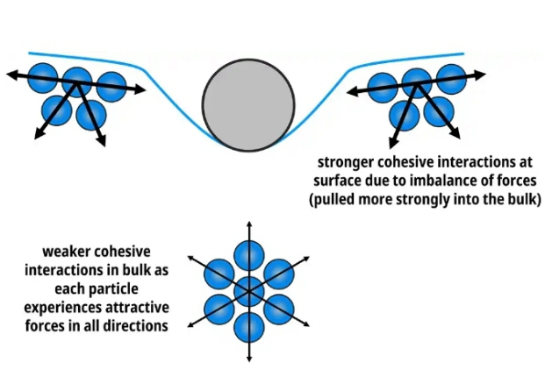
Surface Tension, $γ$, is given by,
$$γ=\frac{F}{L}$$
1

It has a unit of Newton per metre (Nm⁻¹).

Surface Energy: Unlike the surface tension which act along the line over which the force act, surface energy is seen as the sum total of the surface tension force on the whole area of the liquid surface in order words it is seen as the behavior of the liquid surface on the entire surface or area of the liquid.

Relationship between the Surface Tension & Surface Energy
Surface Energy = $\frac{Energy (Workdone)}{Area }$ = $\frac{joules }{m^{2}}$
= $\frac{Newton × m}{m^{2}}$ = $\frac{Newton}{meter}$ = $\frac{Force}{Length}$ = surface Tension
Surface Energy = Surface Tension
$$\frac{E}{A}=\frac{F}{L}$$
2

Factors Affecting Surface Tension
- Addition of Detergent, oil, grease, camphor, soap and ethanol (impurities) affect surface tension by decreasing or lowering surface tension.
- Increase in temperature (or heating) decreases the surface tension as it tends to break or weaken the intermolecular force between the molecules (cohesion) which is responsible for the creation of surface tension,
- By piercing into the surface e.g. with finger or an object.

Measurement of Surface Tension
Capillary Method:
A number of methods are available for measurement of Surface Tension of liquid and one of which is the capillary method.
Explanation of the use of the capillary method
The capillary rise method consists of dipping a thin circular capillary into the liquid to be tested. If the adhesion force (the force of attraction or interaction between the liquid molecules), the capillary tube to a certain length with the meniscus having a concave shape (See Fig. a)
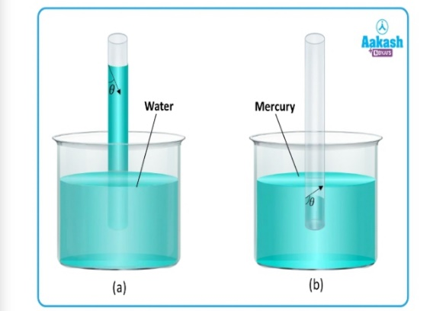
On the other hand, if the adhesion force or adhesion are weaker than the cohesive capillary tube making the meniscus convex (See Figure b).
In order to arrive at the surface tension and capillary rise, $h$ relationship, let’s consider a long, clean capillary tube held vertically on a beaker containing water, the water raised as the capillary tube to a height, $h$ due to surface tension as shown.
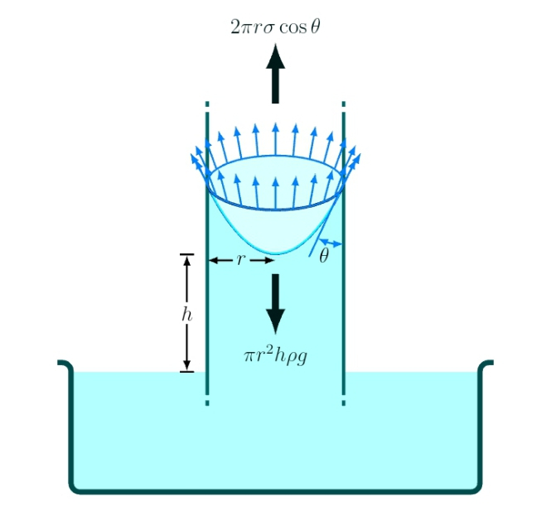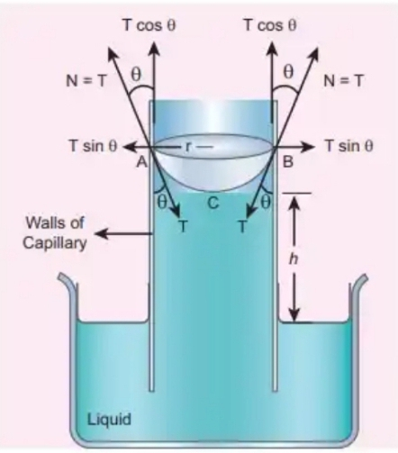
Fig b
Fig a: Capillary rise by surface tension surface tension

The surface tension force F_{T}, acts along the tangent of the point of contact. The surface tension T is resolved into two components, the horizontal component Tsin$θ$ and the vertical component Tcos$θ$ acting upwards all along the whole circumference of the meniscus (see fig a).
At equilibrium, upward force will be equal to downward force (weight of the liquid on the tube).
i.e. upward force (taking all though the circumference) = weight of the liquid above water surface in side beaker.
$\left(γ\cos{θ}\right)(2πr)=mg$ $(NB:surface tension,T=γ)$$\left(2πrγ\cos{θ}\right)=ρvg$
- $2πrγ\cos{θ}=ρπr^{2}hg$ for $v$ = $πr^{2}h$ = vol. of a cylindrical shape of the water that rises up the tube.
- $2γ\cos{θ}=ρrhg$
Or
$$γ=\frac{ρrhg}{2Cosθ}$$

For many liquid including water $θ$ is very close to 0 so that the equation reduces to
$$γ=\frac{ρrhg}{2}$$

Where, $ρ=$ density of the liquid used
$h$ = height through which the cylinder rise on the tube
$g$ = acceleration due to gravity
$r$ = radius of the capillary tube
$θ$= Contact angle/angle between the meniscus and the wall of the tube).
The length, h can be obtained using a traveling microscope or if the surface tension is given, we can write the formula as;
5
$$hr=constant$$
or
$$h=\frac{2γ}{ρghr}$$

Equation (5) is for liquid such as water but with exception of mercury

Solved Problems
- Water rises in a capillary tube to a height of 2.0cm. How much will water rise through another capillary tube whose radius is one – third of the first tube.
Solution
Using equation (5) we can write.
hr = Constant => h₁r₁ = h₂r₂ = constant
let h₁ be the 1st capillary tube rise and $r_{1}$ the radius of the tube and that h₂ and r₂ are the capillary rise and radius of the 2nd tube.
Using h₁r₁ = h₂r₂
=> h₂ = $\frac{h_{1}h_{2}}{r_{2}}$ = $\frac{h_{1}r_{1}}{{1/3r}_{2}} for r_{2}=\frac{r_{1}}{3}$
h₂ ₌ 3 $×$ 2.0 $×$ ${10}^{-2}m$ = 6 $×$ ${10}^{-2}m$
Evidence of Surface Tension
- Sea spider or pond skaters swim on water surface without being wet.
- A liquid e.g. Mercury when smeared across a surface doesn’t wet it but gather up in small droplets or balls.
- The drop of water falling off from a thatched roof or tap, fall off like a stretched elastic skin.
[
DROPS & BUBBLES, ANGLES OF CONTACT
When a liquid comes in contact with a solid surface it generally curve at the point of contact. There exist an angle between these two contact surfaces called the angle of contact.
Definition: Angle of contact is the angle with the tangent to the surface at the point of contact, makes with the solid surface inside the liquid. It is always measured through the liquid. It is denoted by$θ$.
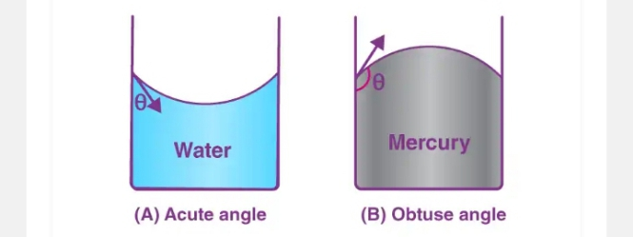
Excess Pressure across a Spherical Surface
(Bubbles and Drops)
Excess pressure difference across a curved or (spherical surface) (e.g. bubbles and drops) can be studied from the Laplace law of spherical membrane.
It states that neglecting the effect of gravity and air resistance, the pressure inside P_{i} is always greater than the pressure outside P_{o} so that the excess pressures is given by P_{i} – P₀
For a liquid drop
Since a liquid drop has one surface the excess pressure will be given by
$$P_{i}-P_{o}=\frac{2γ}{r}$$
1

Where;
$γ$ = Surface Tension
$r$ = Radius of a liquid drop
For Soap Bubble
Since bubbles have two surfaces, the excess pressure will be given by,
$$P_{i}-P_{o}=\frac{4γ}{r}$$

2

Solved Problems
- A raindrop of diameter 4mm is about to fall on the ground. Calculate the pressure inside the raindrop. Surface tension of water is 0.072N/m Atmospheric pressure =1.013 $× {10}^{5}$N/$m^{2}$.
Solution
Given diameter of raindrop = 4mm
Pressure inside = $P_{i}$=? Atmospheric pressure = 1.013 $× {10}^{5}$N/$m^{2}$ = $P_{o}$
Radius = $\frac{D}{2}$ = $\frac{4mm}{2}=2mm$
For a liquid drop, excess pressure is given by
$$P_{i}-P_{o}=\frac{2γ}{r}$$
=> $P_{i}=\frac{2×.0072×1.013×{10}^{5}}{2×{10}^{-2}}=1.01372×{10}^{5}N/m^{2}$

HEAT AND TEMPERATURE
Heat & Internal Energy
Consider a very hot coffee on the top of countertop of your kitchen. Over time both the coffee and the mug will cool down. The question is … what is happening over the course of time to cause the coffee to cool down? The answer will be that the coffee and mug are transferring heat to the surroundings. This transfer of heat occurs from the hot coffee and the mug to the surrounding air. The fact that the coffee lowers its temperature is a sign that the average ki.netic energy of its particles is decreasing. The coffee is losing energy. Same thing applies to the mug.
The energy that is lost by the coffee and the mug is being transferred to the colder surroundings. We refer to this transfer of energy of energy from the coffee and the mug to the surrounding air as heat.
Definition: Heat energy also referred to as thermal energy or simply heat is simply the transfer of energy from a hot object to a colder object.
Heat Vs Temperature
Heat refers to the transfer of energy between systems (or body). In other words, heat is energy, while temperature is a measure of energy. Adding heat will increase body’s temperature while removing heat will lower the temperature, thus, change in temperature are the result of the presence of heat, or conversely, the lack of heat.
Internal Energy
Internal Energy is defined as the sum of Kinetic energy and potential energy of a substance. While heat on the other hand is defined as the transfer of energy from one object to another and is usually the result of the objects with different temperatures.
Differences between Internal Energy & Heat
Internal Energy is actually referring to the movement of particles whereas heat is referring to objects with different temperatures.
Thermodynamics Zeroth Law
As long as temperature difference is maintained, a flow of heat will occur. This flow of heat continues until the objects reach the same temperature. Once their temperatures become equal, they are said to be at thermal equilibrium and the flow of heat no longer takes place. This is the principle of Zeroth law of thermodynamics.
The law states that if two bodies are each in thermal equilibrium with a third body, then the two initial bodies are in thermal equilibrium with each other.
Thermodynamics Temperature Scale
Each thermometer has two reference temperature or fixed parts called the Upper fixed Temperature point and Lower Fixed Temperatures point. The upper fixed temperature point is the temperature of steam from pure water boiling at standard atmospheric pressure of 760mmHg while, the lower the fixed temperature point is the temperature of pure melting ice at a standard atmospheric pressure of 760mmHg.
The difference in temperature between the two temperature points is called the fundamental interval (or temperature interval) of a thermometer. The calibration of this interval depends on the temperature scale used. There are three types of scale in current use;
- The Celsius scale
- The Fahrenheit scale
- Absolute (or thermodynamic or kelvin) scale.
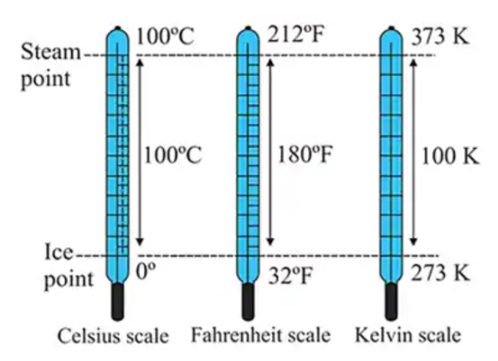
The lower and upper fixed points are 0ºC and 100ºC for the Celsius scale. This follows that the temperature interval in the Celsius scale is divided into100 equal parts each defining 1ºC. For the Fahrenheit scale, the upper and lower fixed temperature points are 212ºF and 32 ºF. The fundamental interval is divided into 180 Unit or degree (ºF) (212 – 32 = 180).
The SI unit of temperature is the Kelvin K and its scale is called the Absolute or thermodynamic temperature scale. The fundamental interval for the Kevin scale goes from a lower fixed point of 273K to an upper fixed point of 373K. i.e., a difference of 100K. This interval is divided into 100K equal points each of which defines 1K.
NB: the Unit symbol K is written without the degree sign.
Relationship between Kelvin scale & Celsius Scale
The lower fixed point or the Zero on the Kelvin scale is equal to -273 ºC. it is also called the absolute zero.
Hence – 273 ºC = 0K or 0 ºC = 273K
This generally shows that a temperature of 0ºC in the Celsius scale is related to the temperature T in Kelvin scale by
$$T+θ=273$$

TYPES OF THERMOMETERS
- Liquid in gas thermometer
- The Gas thermometer
- Resistance thermometer
- Thermocouple
- Bimetallic thermometer

Solved Problems
The lower and upper fixed parts of a certain thermometer are 30cm apart. At a certain day, the length of mercury thread in the thermometer is 9cm above this ice part (0ºC). What is the temp required by the thermometer in both Celsius and Kelvin scales.
Solution
Taking proportion we get;
$$\frac{AB}{AC}= \frac{DE}{DF}= \frac{9}{30}= \frac{θ}{100}= \frac{3}{10}$$
- Hence $θ= {30}^{o}$C
- In Kelvin, T = $θ+273= {30}^{o}$C + 273 = 303K

